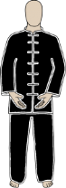Stand with feet about shoulder distance apart
Brings hands up in front of body - Palms up - inhale - bring to heart level – turn palms down and lower arms 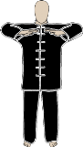while exhaling. Do this three times
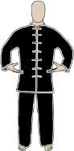Turn palms up - Inhale - Bring arms out to the side as far as finger tips to edge of body
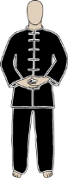Exhale - bring arms down - Rest hands - right hand on top of left - tips of thumbs touching - Pause here
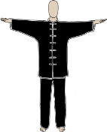Inhale - Arms raise out to the side then to front 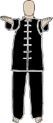- bring in towards body - 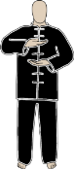palms up - right hand above left
Turn right hand palm down - exhaling lower hands - left hand below navel right hand above - Pause here
Exhale - right hand moves down to left hand then turn hands - finger tips towards the Earth
Inhale bringing arms out and up over head - Exhale bringing down into prayer posture 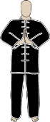- Pause here
Exhale - extend arms out in front of you - palms out - fingers up - Pause here
Inhale bringing hands towards body - palms up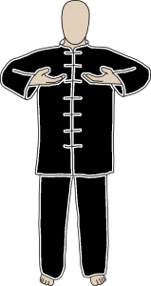
Exhale extending arms out to the side - palms out - fingers pointing up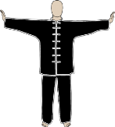
Do this three times and Pause on the third time of arms extended to side – Pause here
Inhale bringing arms to front - bring hands toward body - palms up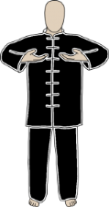
Exhale turn hands - palms up and bring arms over head
Inhale bring arms down to the side around to front -palms up - then bringing in to body and over your head again
Do this three times and Pause on the third time with arms above head – Pause here
Exhaling slowly bring hands down in front of body - palms down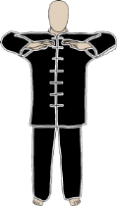
Inhaling bring arms out and up and again exhaling down the front of body
Do this three times then pause with right hand resting on left - palms up - Pause here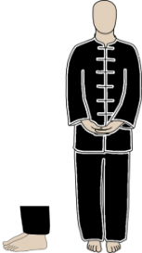
Lace fingers together - inhale bringing hands up to heart level and raising up on toes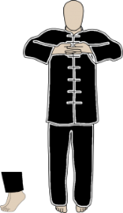
Big exhalation through nose or mouth as you drop down on your heels and bring hands down
Do this three times then rest - Pause - with fingers laced - palms up - Pause here
Inhale bring arms out to the side then up - and exhale slowly down the front of the body palms down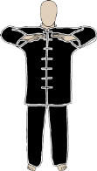
Do this three times
Rest in whatever position is right for your practice

